BST_2

Ex. 20.2, p 800

Quan Truong

The Distinguished Professor Victoria Heil

CSC205

Binary Search Tree #2

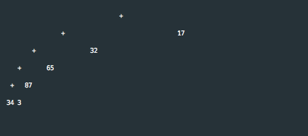

Explanation: The preceding tree is much smaller than the following tree because it has less branches.

